Assignment 2 – Risk Identification

ALY6130: Risk Management for Analytics
Dr. Abeba N. Turi
Master of Professional Studies in Analytics, Northeastern University
Group 3: Victory Louis, Musa Oseni Oyakhire, Chenlu Liu
June 4th, 2026

Contents
Background 4
Core Risk 1 - Cybersecurity & Data Privacy Risk 5
SWOT Connection 5
Problem Statement 5
Risk Type 6
Key Leading KRI 6
Traffic Light Thresholds 6
Controls & Mitigation Strategies 7
Core Risk 2 - Technology Reliability & AI Integration Risk 9
SWOT Connection 9
Risk Analysis 9
Problem Statement 10
Risk Type 10
Key KRI 11
Traffic Light Thresholds 12
Controls 13
Monitoring, Escalation and Reporting 13
Conclusion 14
Core Risk 3 - AI-driven Market Expansion Opportunity 15
SWOT Connection 15
Problem Statement 15
Risk Type 16
Positive Risk 16
Strategic / Market Opportunity Risk 16
Key KRI 17
Traffic Light Thresholds 18
Controls 18
Green Level (Retention Rate Above 90%) 18
Amber Level (Retention Rate Between 75%–90%) 19
Red Level (Retention Rate Below 75%) 19
References 19
Appendix A – Risk Register and KRIs 21
Appendix B – KRI Type and Description 24

Amazon Acquiring an AI-Powered Customer Service Platform

Background
Amazon, as one of the most influential global companies, is currently expanding the application of artificial intelligence technologies to strengthen its long-term competitive position within the global digital service market. As AI-driven customer service solutions become increasingly important across multiple industries, Amazon is exploring the integration and expansion of AI-powered customer support systems capable of providing automated assistance, personalized interactions, and scalable service operations. However, rapid technological advancement, increasing competition within the global AI market across various industries, evolving customer expectations, and growing cybersecurity concerns also introduce significant strategic and operational risks. These risks require continuous monitoring and effective Enterprise Risk Management (ERM).
Based on the existing SWOT analysis and the current competitive environment, this report aims to examine Amazon’s AI-driven customer service expansion strategy. The analysis identifies three core risks:
- Cybersecurity and Data Privacy Risk
- Technology Reliability and AI Integration Risk
- AI-driven Market Expansion Opportunity
These risks include both negative and positive competitive pressures that may influence Amazon’s strategic growth, operational performance, customer retention, and long-term market positioning within both the Canadian and global AI service industry.
The following sections provide a detailed analysis of each core risk, including the SWOT connection, problem statement, risk type, key leading Key Risk Indicator (KRI), traffic light threshold levels, and proposed controls to support continuous risk monitoring and strategic decision-making.

Core Risk 1 - Cybersecurity & Data Privacy Risk
This risk maps directly to a key Threat identified in the SWOT analysis: the growing exposure to cybersecurity breaches and data privacy violations as the organisation scales its digital and AI-driven operations.

SWOT Connection
SWOT Element | Description
Threat (T1) | Increasing frequency and sophistication of cyberattacks targeting organisations that handle sensitive customer and operational data, compounded by expanding AI infrastructure and third-party integrations.
Weakness Link (W) | Potential gaps in cybersecurity maturity, staff awareness, and data governance frameworks as the organisation rapidly adopts new technologies and AI systems.
Table 1.1: SWOT Connection

Problem Statement
As the organisation accelerates its adoption of AI technologies and expands its digital service offerings, it is processing and storing increasing volumes of sensitive customer, financial, and operational data. This creates a materially elevated exposure to cybersecurity threats, including data breaches, ransomware, unauthorised access, and regulatory non-compliance.
At the current stage of growth, the organisation may not yet have fully mature security controls, incident response capabilities, or data privacy governance frameworks to match the pace of its digital transformation. A successful cyberattack or data privacy breach could result in:
- Significant financial penalties under data protection regulations (e.g., GDPR, PDPA, or equivalent)
- Reputational damage and erosion of customer trust
- Operational disruption and system downtime
- Loss of competitive advantage through intellectual property theft
Active monitoring of cybersecurity risk indicators is therefore critical to provide early warning of deteriorating security posture before a breach or regulatory breach occurs.

Risk Type
Attribute | Detail
Risk Orientation | Negative Risk — this risk represents a potential downside event that must be prevented or mitigated.
Risk Category | Operational Risk / Technology Risk / Compliance & Regulatory Risk
Risk Driver | Rapid digital expansion, AI system integration, third-party vendor dependencies, and evolving regulatory requirements.
Table 1.2: Risk Type

Key Leading KRI
KRI Field | Detail
Selected KRI | Number of Critical or High-Severity Unresolved Security Vulnerabilities (per month)
Why Leading? | Unresolved vulnerabilities are a precursor to potential exploitation. Tracking their volume and severity provides advance warning of rising breach likelihood before an incident occurs.
Data Source | Internal vulnerability scanning tools (e.g. Tenable, Qualys, or equivalent), penetration testing reports, and IT security dashboards.
Measurement Frequency | Monthly reporting, with real-time alerting for any new Critical-severity findings.
Table 1.3: Leading KRIs for Core Risk One

Traffic Light Thresholds
Thresholds apply to the monthly count of unresolved Critical or High-severity security vulnerabilities outstanding beyond their SLA remediation period.

Status | Level | KRI Threshold | Trigger Condition
GREEN | Within Tolerance | 0 Critical / ≤2 High unresolved past SLA | Security posture is sound. All critical vulnerabilities remediated within SLA. Normal monitoring continues.
AMBER | Elevated — Monitor Closely | 1–2 Critical OR 3–5 High unresolved past SLA | Escalation required. Security team must present remediation plan within 5 business days.
RED | Breach — Immediate Action | ≥3 Critical OR ≥6 High unresolved past SLA | Immediate escalation to senior management. Incident response activated. Executive notification within 24 hours.
Table 1.4: Traffic Light Threshold

Controls & Mitigation Strategies
Preventive Controls
- Implement a formal vulnerability management programme with defined SLAs for remediation by severity (e.g. Critical: 24 hrs, High: 7 days, Medium: 30 days).
- Conduct regular penetration testing (minimum quarterly) and automated vulnerability scanning of all systems, including AI infrastructure.
- Enforce a data classification policy to ensure sensitive data is identified, access-controlled, and encrypted both in transit and at rest.
- Apply multi-factor authentication (MFA) and least-privilege access controls across all systems and third-party integrations.
Detective Controls
- Deploy a Security Information and Event Management (SIEM) system for real-time monitoring, anomaly detection, and alerting on suspicious activity.
- Maintain an up-to-date asset inventory and monitor all endpoints, cloud services, and AI systems for unusual behaviour.
- Conduct monthly security posture reviews, tracking the selected KRI and reporting results to the Risk Committee.
Corrective Controls
- Maintain and regularly test a documented Incident Response Plan (IRP), including escalation paths, communication protocols, and recovery procedures.
- Ensure cyber liability insurance is in place and reviewed annually to cover breach-related costs, regulatory fines, and business interruption.
- Establish a mandatory data breach notification process aligned with applicable regulatory timelines (e.g. 72-hour GDPR notification window).
People & Awareness Controls
- Deliver mandatory cybersecurity awareness training for all staff at onboarding and annually thereafter, including phishing simulations.
- Designate a Data Protection Officer (DPO) or equivalent role responsible for overseeing data privacy compliance and regulatory engagement.

Core Risk 2 - Technology Reliability & AI Integration Risk

SWOT Connection
This core risk is mainly related to:
W1: Increased Dependence on Technology and System Reliability
Large-scale AI-driven customer service operations require stable system performance, accurate AI responses, real-time processing capabilities, and seamless integration across multiple digital platforms. Any technical disruption may directly affect customer experience, operational continuity, and business performance.
T1: Rapid Technology Obsolescence and AI Algorithm Evolution
As customer expectations and industry standards continue rising, Amazon faces growing pressure to maintain stable AI performance while continuously upgrading its systems and integrating new technologies. Failure to maintain reliable AI operations or successfully integrate evolving AI technologies may reduce customer confidence, weaken operational efficiency, and negatively affect Amazon’s long-term competitive positioning within the enterprise AI service market.

Risk Analysis
Technology Reliability & AI Integration Risk means that there is a risk that critical technology systems and infrastructure fail to deliver reliable, available, and consistent service, probably resulting in operational disruption, financial loss, regulatory breach, and reputational harm to Amazon.
The risk of technology reliability failure and unsuccessful AI system integration is caused by Amazon’s increasing dependence on cloud infrastructure, AI-powered customer service systems, machine learning models, and large-scale enterprise platform integration. As Amazon continues expanding its AI-driven customer service ecosystem across multiple industries, system complexity, integration challenges, and technological dependencies also increase significantly.
At the same time, rapid technological advancement within the global AI market creates continuous pressure for Amazon to update and integrate evolving AI technologies while maintaining stable operational performance. Competitors such as Microsoft, Google, Salesforce, and IBM are aggressively improving their AI infrastructure and enterprise AI service capabilities, increasing competitive expectations for system reliability, scalability, and AI performance.
If Amazon fails to maintain reliable AI system performance or experiences integration failures between AI platforms, cloud services, and existing operational systems, this may result in operational disruptions, inaccurate AI responses, service downtime, reduced customer satisfaction, lower enterprise customer adoption, and weakened competitive advantage within the global AI service industry.
Therefore, continuous monitoring of technology reliability and AI integration performance is necessary to provide early warning signals before major operational failures or service disruptions occur.

Problem Statement
The organisation depends on a large and growing estate of applications, platforms and infrastructure that must operate continuously to support customers, employees and regulated processes. Several structural conditions raise the likelihood and impact of reliability failures:
- Ageing and legacy infrastructure that is costly to maintain and increasingly difficult to support.
- Single points of failure and limited redundancy across parts of the estate, so that one component failure can cascade into a wider outage.
- Capacity constraints driven by rising transaction volumes that push systems beyond their designed limits at peak.
- Change related instability, where a meaningful share of incidents originate from changes that were poorly tested or released.
- Monitoring that is largely reactive, so that problems are often detected by customers rather than by the organisation.
- Concentration on a small number of third party and cloud providers, which transfers part of the reliability exposure outside direct control.
In combination these conditions mean that outages are not rare or purely random events but the predictable outcome of known weaknesses. The problem this assessment addresses is how to measure, threshold and control technology reliability so that the exposure is reduced to within risk appetite and managed proactively rather than after the fact.

Risk Type
Technology reliability risk is classified as a non financial, operational risk. It is most closely aligned with the business disruption and system failure event category and sits within the wider technology and information risk taxonomy.
Classification dimension | Assessment
Primary category | Operational risk (non financial)
Sub category | Technology and information risk
Event type | Business disruption and system failures
Risk nature | Largely internal cause with external amplifiers
Velocity | High. Impact can be immediate once a failure occurs
Manageability | Controllable through architecture, monitoring and change discipline
Appetite | Low. The organisation seeks high availability of critical services
Table 2.1: Risk Type
Classifying the risk in this way allows it to be reported within the operational risk framework, mapped to recognised control libraries and aggregated with other operational exposures for governance and capital purposes (ISACA, 2019).

Key KRI
Key risk indicators provide an early and measurable signal of changes in the exposure. The indicators below cover availability, recovery, stability and capacity, which together describe the reliability of the estate.
Key risk indicator | What it measures | Why it matters
System availability | Percentage of time critical services are available | Direct measure of reliability against service commitments
Mean time to recovery | Average time to restore service after an incident | Shows how quickly the organisation recovers from failure
Priority 1 incidents | Count of critical incidents per month | Indicates frequency of severe reliability events
Change failure rate | Share of changes that cause an incident or rollback | Links instability to weak change management
Capacity utilisation | Peak use of compute, storage and network | Warns of failures driven by demand exceeding capacity
Backup success rate | Share of scheduled backups completing successfully | Underpins recoverability and data availability
Table 2.2: KRI

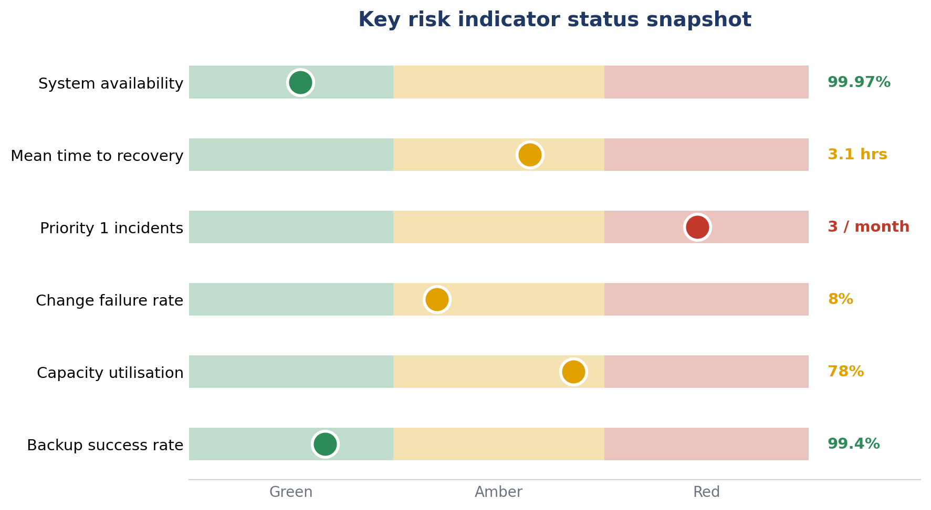
Figure 2.2. Current status of each key risk indicator on a green to red scale.
The current snapshot shows priority 1 incidents in red and recovery time, change failure rate and capacity utilisation in amber. Availability and backup success remain green. The pattern is consistent with the problem statement, pointing to instability and capacity pressure rather than a single isolated fault.

Traffic Light Thresholds
Each indicator is governed by traffic light thresholds. Green is within appetite, amber is a warning that requires review and a remediation plan, and red is a breach that requires escalation and management action.
Indicator | Green | Amber | Red | Red action
System availability | ≥ 99.95% | 99.5 to 99.95% | < 99.5% | Escalate to head of technology
Mean time to recovery | ≤ 2 hrs | 2 to 4 hrs | > 4 hrs | Invoke major incident review
Priority 1 incidents | 0 per month | 1 to 2 | ≥ 3 | Root cause and board reporting
Change failure rate | ≤ 5% | 5 to 10% | > 10% | Freeze non urgent changes
Capacity utilisation | ≤ 70% | 70 to 85% | > 85% | Approve capacity uplift
Backup success rate | ≥ 99% | 95 to 99% | < 95% | Remediate backup failures

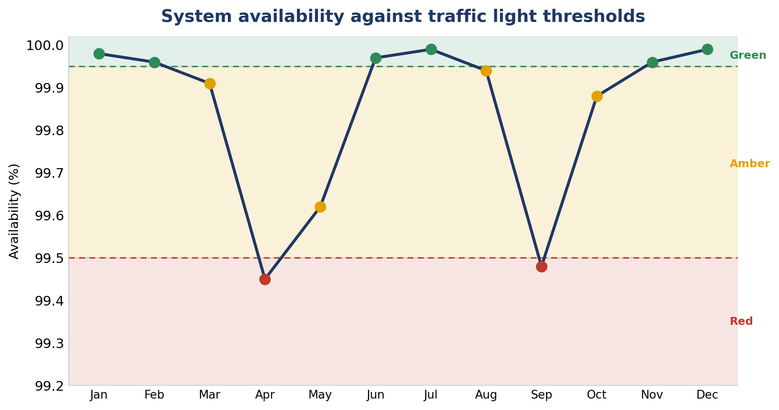
Figure 2.3. Twelve month availability trend with green, amber and red threshold bands.
The trend shows availability breaching the red threshold twice during the year, in both cases linked to outages on parts of the legacy estate. These breaches drive the elevated residual rating and reinforce the case for the remediation set out below.

Controls
Controls are grouped as preventive, detective and corrective. Preventive controls reduce the likelihood of failure, detective controls identify problems early, and corrective controls limit the impact and restore service quickly.
Type | Control | Risk addressed
Preventive | Resilient architecture with redundancy and high availability across critical services | Single points of failure and outages
Preventive | Capacity and demand management with forward looking forecasting | Failures driven by demand exceeding capacity
Preventive | Disciplined change management with testing, approval and release control | Change related instability
Preventive | Lifecycle and patch management to retire end of life assets | Ageing and unsupported infrastructure
Detective | Real time monitoring, alerting and indicator dashboards | Late detection of degradation and outages
Detective | Synthetic transaction monitoring and periodic recovery testing | Undetected service and recovery failures
Corrective | Major incident management with defined roles and escalation | Slow or disorganised response to failure
Corrective | Automated failover and tested rollback procedures | Prolonged downtime during an incident
Corrective | Root cause and problem management to prevent recurrence | Repeat incidents from the same cause
Table 2.3: Risk Control
The control set draws on recognised service management and risk guidance, including frameworks for change, incident and problem management and for the governance of enterprise technology (AXELOS, 2019; ISACA, 2019). The priority gap is the shift from reactive to predictive monitoring, which is the opportunity most able to reduce residual risk.

Monitoring, Escalation and Reporting
Indicators are measured monthly, with critical availability metrics monitored continuously. Amber readings require a documented remediation plan with an owner and a target date. Red readings are escalated to senior technology management and, where appetite is breached, reported to the relevant risk committee. The approach follows a structured cycle of identification, assessment, treatment and monitoring consistent with established risk management guidance (Hopkin, 2018; International Organization for Standardization, 2018; National Institute of Standards and Technology, 2012).

Conclusion
Technology reliability risk is a material operational exposure that is driven mainly by internal weaknesses and amplified by external threats. The indicators and thresholds in this assessment make the exposure measurable, and the control set provides a sound foundation. Residual risk is currently elevated, evidenced by recurring critical incidents and threshold breaches. Reducing it depends on executing the opportunities identified in the SWOT, in particular the move to predictive monitoring, the removal of single points of failure and the modernisation of the legacy estate.

Core Risk 3 - AI-driven Market Expansion Opportunity

SWOT Connection
This core risk is mainly related to:
O1: Expansion into New Customer Service Market Segments
Amazon can expand beyond traditional e-commerce operations by leveraging AWS and AI-powered customer service technologies to enter growing enterprise AI support markets, including cloud-based contact centers, automated customer support, and generative AI business solutions.
O3: Enhanced Customer Experience and Competitive Differentiation
As organizations increasingly adopt AI-driven customer support systems, Amazon has the opportunity to differentiate itself through scalable cloud infrastructure, integrated AI services, and personalized customer experience solutions. Growing demand for cost-efficient and reliable AI platforms may also attract customers seeking alternatives to competing AI service providers.

Problem Statement
Amazon is currently expanding its AI-driven customer service ecosystem. Some of Amazon’s major AI-powered service systems include its well-known cloud computing platform, Amazon Web Services (AWS), as well as AI customer service and generative AI tools such as Amazon Bedrock, Amazon Lex, and Amazon Connect. This demonstrates that Amazon is not only an e-commerce company. Its business operations also include AWS cloud services, enterprise AI services, intelligent customer support systems, and generative AI infrastructure. Therefore, this core risk emerges because Amazon is leveraging AWS and AI customer service technologies to expand into the enterprise AI service market.
In terms of competition, Amazon operates within two different competitive environments. First, at the e-commerce level, competitors include retail platforms such as Temu, Walmart, Alibaba, and Shopify. Second, within the AI cloud service and enterprise AI market, Amazon competes with companies such as Microsoft Azure + OpenAI, Google Cloud + Gemini, I
The opportunity created by this competition comes from the rapid expansion of the AI customer service market. Increasingly, organizations want to reduce human customer service costs, improve response speed, provide 24/7 support, and enhance customer scalability. As a result, many businesses are actively searching for AI-powered customer service providers. However, many existing platforms face challenges such as high operating costs, complex integration processes, limited customization capabilities, and inconsistent AI accuracy, which may lead to customer loss.
If Amazon can leverage its AWS infrastructure, cloud scalability, and existing customer ecosystem to develop more advanced AI capabilities and deliver more scalable, integrated, and cost-efficient AI customer service solutions, the company may attract enterprise customers away from competing AI platforms. This represents a new market expansion opportunity for Amazon.

Risk Type

Positive Risk
This is considered a positive risk because successful expansion within the AI-driven customer service market may create significant strategic growth opportunities for Amazon. As global demand for AI-powered customer support solutions continues increasing, Amazon has the opportunity to expand its enterprise AI service ecosystem beyond traditional e-commerce operations.
By leveraging AWS infrastructure, generative AI technologies, and scalable cloud-based customer service solutions, Amazon may strengthen its competitive advantage, attract enterprise customers from competing AI platforms, and improve long-term business performance. Successful market expansion may also increase customer retention, improve operational efficiency, and create new revenue streams across multiple industries including healthcare, finance, telecommunications, and enterprise support services.
However, the opportunity also contains uncertainty because the AI industry is evolving rapidly. Competitors are continuously investing in advanced generative AI technologies, customer service automation, and enterprise cloud platforms. If Amazon fails to adapt quickly to changing market expectations, customer adoption trends, and technological innovation, the company may lose potential growth opportunities and weaken its competitive positioning within the global AI service market.

Strategic / Market Opportunity Risk
This opportunity is classified as a Strategic and Market Opportunity Risk because it directly influences Amazon’s long-term growth strategy, competitive positioning, and expansion into emerging AI service markets.
The rapid growth of AI-powered customer service technologies is transforming how organizations interact with customers, manage support operations, and scale business services. As businesses increasingly adopt AI-driven automation to reduce operational costs and improve customer experience, Amazon has an opportunity to position itself as a leading enterprise AI service provider through AWS and its AI-powered platforms such as Amazon Bedrock, Amazon Lex, and Amazon Connect.
This opportunity mainly affects:
- Strategic growth and global market expansion
- Customer experience and customer retention
- Operational scalability and automation efficiency
- Revenue growth and long-term profitability
- Enterprise AI adoption and customer acquisition
- Competitive positioning within the global AI industry
- Innovation capability and technological leadership
Because the AI market is highly competitive and rapidly evolving, continuous monitoring of customer adoption, competitor activity, technological advancement, and market demand is necessary to ensure Amazon can successfully capture emerging business opportunities while maintaining sustainable long-term growth.

Key KRI
Category | Related Risk / Opportunity | Why It Is Highly Related | Related KRI
Strategic Risk | Competitors implementing superior AI technologies | Major competitors such as Microsoft, Google, and Salesforce are rapidly investing in enterprise AI solutions. | Customer Growth Rate (%)
Strategic Risk | Failure to maintain competitive advantage in AI services | Amazon may lose long-term market positioning if competitors innovate faster. | Market Share Growth (%)
Market Opportunity Risk | Expansion into enterprise AI service markets | Amazon is using AWS, Bedrock, Lex, and Connect to expand beyond e-commerce into enterprise AI services. | Enterprise Customer Adoption Rate (%)
Customer Risk | Slower customer adoption of AI customer service platforms | Businesses may hesitate to adopt AI systems because of trust, privacy, or integration concerns. | Customer Adoption Rate (%)
Customer Risk | Customer migration to competing AI platforms | Customers may move toward platforms with lower cost or stronger AI capabilities. | Customer Retention Rate (%)
Table 3.1: Top 5 Relevant KRIs
According to Appendix A, the five most relevant risks and KRIs related to Amazon’s AI-driven market expansion opportunity are summarized in Table 1. Most of the identified risks are directly connected to customer behavior, customer adoption, and long-term customer relationships within the enterprise AI service market.
Among these KRIs, Customer Retention Rate (%) was selected as the most representative indicator for further analysis because it directly reflects Amazon’s ability to maintain enterprise customers within its AI-powered customer service ecosystem. Since the AI market is highly competitive and rapidly evolving, retaining existing enterprise customers is critical for sustaining long-term market expansion, competitive positioning, and revenue growth.
A declining customer retention rate may indicate increasing competitive pressure, lower customer satisfaction, weak AI performance, or customer migration toward competing AI platforms such as Microsoft Azure, Google Cloud, or Salesforce AI. In contrast, strong customer retention may demonstrate successful customer adoption, effective AI integration, and sustainable competitive advantage.
Therefore, Customer Retention Rate (%) was selected to develop the Traffic Light Threshold analysis and related control measures to support continuous monitoring of Amazon’s AI market expansion performance and strategic growth opportunities.

Traffic Light Thresholds
Customer Retention Rate (%)
Level | Threshold | Description
Green | Retention rate above 90% | Strong customer loyalty and successful AI service adoption
Amber | Retention rate between 75%–90% | Moderate retention; customer monitoring and service improvement required
Red | Retention rate below 75% | High customer loss risk; competitive position and market expansion objectives at risk
Table 3.2: Traffic Light Thresholds
The thresholds were developed based on general enterprise software and customer retention benchmarking logic within competitive AI and cloud service industries. Higher retention rates are commonly associated with stronger customer satisfaction, successful platform integration, and sustainable long-term customer relationships, while declining retention rates may indicate increasing competitive pressure, weak customer adoption, or customer migration toward alternative AI service providers.

Controls

Green Level (Retention Rate Above 90%)
When customer retention remains above 90%, Amazon should continue supporting long-term market expansion by maintaining high AI service quality and strengthening customer relationships. At this stage, the focus should remain on continuous innovation and sustainable competitive advantage. Control actions include:
- Continuous AI model improvement
- Ongoing investment in AI innovation and R&D
- Expansion into additional enterprise markets
- Enhancement of customer experience and personalization
- Cross-platform customer service integration

Amber Level (Retention Rate Between 75%–90%)
When customer retention begins declining into the amber zone, Amazon should increase monitoring activities and identify potential causes of customer dissatisfaction or competitive pressure. Moderate declines may indicate early warning signs related to AI performance, customer adoption challenges, or stronger competitor offerings. Control actions include:
- Increased customer feedback and satisfaction analysis
- Enhanced market trend and competitor monitoring
- AI performance testing and service optimization
- Review of enterprise customer support strategies
- Targeted customer retention initiatives

Red Level (Retention Rate Below 75%)
When customer retention falls below 75%, Amazon should implement immediate strategic and operational corrective actions. This level may indicate serious customer migration, reduced competitive positioning, or major weaknesses within AI service performance and customer engagement. Control actions include:
- Immediate executive-level risk review
- Intensive customer retention and recovery strategies
- Rapid AI system improvement and issue resolution
- Competitive pricing and service reassessment
- Strategic review of AI market expansion plans
- Increased investment in customer support and platform reliability

References
Ali, A., Warren, D., & Mathiassen, L. (2017). Cloud-based business services innovation: A risk management model. International Journal of Information Management, 37(6), 639-649.
Amazon. (2025). About Amazon. Amazon Official Website
Amazon Web Services (AWS). (2025). Cloud computing services and security infrastructure.
AXELOS. (2019). ITIL foundation: ITIL 4 edition. The Stationery Office.
Basel Committee on Banking Supervision. (2011). Principles for the sound management of operational risk. Bank for International Settlements.
Bello, K. L., Baidoo, M. I. K., & Umapathi, M. M. (2026). AI-Based Customer Relationship Management And Its Effect On Customer Retention. Int. J. Adv. Res. Sci. Technol. Volume, 15(3), 1805-1814.
Galletta, A., Carnevale, L., Celesti, A., Fazio, M., & Villari, M. (2017). A cloud-based system for improving retention marketing loyalty programs in industry 4.0: a study on big data storage implications. IEEE Access, 6, 5485-5492.
Hopkin, P. (2018). Fundamentals of risk management: Understanding, evaluating and implementing effective risk management (5th ed.). Kogan Page.
International Organization for Standardization. (2018). ISO 31000:2018 risk management: Guidelines. ISO.
ISACA. (2019). COBIT 2019 framework: Governance and management objectives. ISACA.
Md Musfiqur Rahman, & Md.Kamrul Khan. (2023). MECHANISMS BY WHICH AI-ENABLED CRM SYSTEMS INFLUENCE CUSTOMER RETENTION AND OVERALL BUSINESS PERFORMANCE: A SYSTEMATIC LITERATURE REVIEW OF EMPIRICAL FINDINGS. International Journal of Business and Economics Insights, 3(1), 31-67. https://doi.org/10.63125/qqe2bm11
National Institute of Standards and Technology. (2012). Guide for conducting risk assessments (Special Publication 800.30, Revision 1). U.S. Department of Commerce.

Appendix A – Risk Register and KRIs
Risk Category | Specific Risk | Caused by | Potential Impact | Example KRI | KRI Type
Strategic | Failure of AI warehouse strategy to achieve expected efficiency gains | Poor implementation planning | Reduced competitive advantage | Warehouse productivity improvement rate (%) | Process
 | Public backlash over workforce replacement | Concerns about job displacement due to automation | Reputation damage | Customer sentiment score / negative media mentions | Other
 | Competitors implementing superior warehouse technology | Rapid innovation by competitors | Loss of market share | Market share change (%) | Other
 | Dependence on third party technology vendors | External technology providers | Reduced operational flexibility | Vendor system availability (%) | Technology
Operational | Warehouse operations interruption | System downtime | Delivery delays | Total system downtime hours | Process
 | Robotic picking failure | Robot arm or sensor malfunction | Incorrect order processing | Robot failure frequency (#/week) | Facilities
 | Autonomous mobile robot collision | Navigation system errors | Operational disruption and safety concerns | Number of robot collision incidents | Facilities
 | Inventory misplacement | AI sorting errors | Inventory inaccuracies | Inventory accuracy rate (%) | Process
 | Order fulfillment errors | Incorrect AI predictions | Customer complaints | Order accuracy rate (%) | Process
 | Supply chain disruption | Vendor delays | Inventory shortages | Supplier on time delivery rate (%) | Process
 | Warehouse congestion | Robot traffic inefficiencies | Reduced productivity | Average order processing time | Process
 | Increased employee turnover | Employee concerns over automation | Staffing shortages | Employee turnover rate (%) | People
 | Employee resistance to AI systems | Lack of trust or insufficient training | Lower productivity | Employee satisfaction score | People
 | Insufficient employee training | Rapid implementation | Improper system use | Training completion rate (%) | People
Technology | AI prediction inaccuracies | Biased or incomplete training data | Poor decision making | AI prediction accuracy (%) | Technology
 | Failure of AI demand forecasting | Incorrect data models | Overstocking or stockouts | Forecast error rate (%) | Technology
 | Software update failures | Programming errors | System instability | Failed software updates (#/month) | Technology
 | Integration failure between legacy systems and AI systems | Compatibility issues | Process interruption | Integration success rate (%) | Technology
 | Sensor malfunction | Hardware failures | Wrong warehouse actions | Sensor error frequency | Facilities
 | Cloud service outage | Cloud platform failures | Warehouse shutdown | System uptime (%) | Technology
 | Data quality issues | Missing or inconsistent data | Reduced model performance | Data accuracy/completeness rate (%) | Technology
Information Security | Customer data breach | Weak security controls | Legal and reputational damage | Number of security incidents | Technology
 | Unauthorized system access | Weak access management | System compromise | Failed login attempts | Technology
 | Ransomware attacks | Cybersecurity vulnerabilities | Operational shutdown | Number of cybersecurity incidents | Technology
 | API security vulnerabilities | Weak API configurations | Data exposure | Number of detected API vulnerabilities | Technology
 | Insider threats | Misuse by employees | Data leakage | Number of unauthorized internal activities | People
 | IoT device hacking | Connected robot vulnerabilities | Operational disruption | IoT security alerts | Technology
Financial | Higher than expected implementation costs | Technology investment requirements | Reduced profitability | Budget variance (%) | Other
 | Cost overruns | Unexpected expenses | Budget pressure | Cost overrun percentage | Other
 | Delayed ROI | Lower than expected efficiency improvements | Financial loss | Return on investment (%) | Other
 | Revenue loss from delivery disruptions | Operational failures | Customer loss | Revenue loss amount ($) | Other
Compliance | Data privacy violations | Improper data handling | Fines and penalties | Compliance violation count | Technology
 | Workplace safety regulation violations | Human robot interactions | Legal action | Safety incident frequency | Facilities
 | AI ethics concerns | Bias in automated decisions | Regulatory scrutiny | Number of bias reports | Other
Governance | Weak risk oversight | Inadequate risk management processes | Delayed issue detection | Risk review frequency | Process
 | Communication gaps across departments | Poor coordination | Project delays | Number of escalated project issues | People
 | Poor change management | Resistance to operational changes | Low adoption rate | Employee adoption rate (%) | People

Appendix B – KRI Type and Description
KRI Type | Description
People | Employee related factors including workforce, training, communication, and internal employee behavior
Process | Operational processes including warehouse workflow, order fulfillment, supply chain management, and risk management processes
Technology | Technology related elements including AI systems, software, data, cloud platforms, and security systems
Facilities | Physical infrastructure including robots, sensors, equipment, and workplace environment
Other | External and business related factors including market conditions, reputation, financial performance, and strategic considerations

